**Workshop Report**

**1730026051 李殷 1730026124 徐浚开 1730026133杨穆雪**

1 Data Collection

1.1 Collection method

First part is search data. At first our group use the dataset as our database, but it can not use for real-time information search. So, I write a web crawler program to collect the data we need.

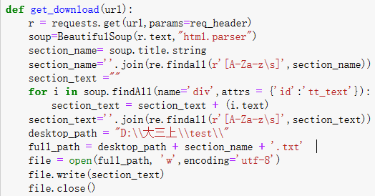

This program is designed to get an English novel website’s article. This program needs to import the BeautifulSoup to run the program. Its operation principle is that it can browse the selected webpage to copy the novel and then put it in a file. And this program can copy all of one book’s sections each time. Then, at last pack as a txt file. Also, I use a regular expression to filter the strings and only leave the letters. At last, I put the database into the map-reduce JAVA program to get the index and rank.

1.2 Improvement

This web crawler just can get the result once and can’t get the newest results. So, to catch the information immediately, we need to write a dynamic web crawler program. First, this program needs to keep on refreshing the data and change the old data to new. So, this part needs a database to store the data which can help us to cover the old information conveniently. Or we need to write a program to find out the old data and use a new data to cover it dynamically. The second step is that put the data into map-reduce program. Because the database change dynamically, so all of the operations need to write in one program and then this program can run all of programs each time. So, I need to set a time limitation to refresh the database.

2 Index

2.1 Python

I use the Python to get the index of each word.

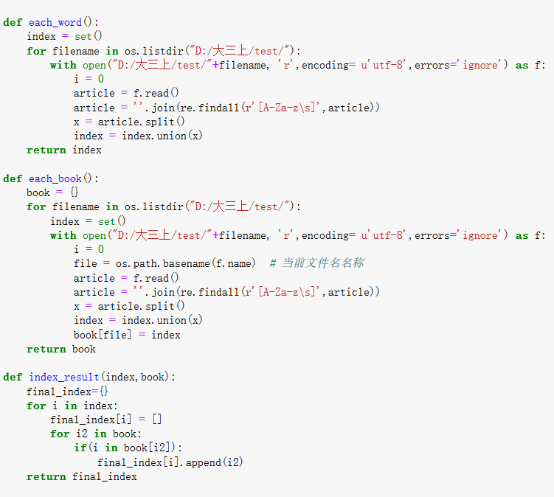

First function is used to find out each word has appeared in the database. This program can use the set() to get a dictionary of all of the words. Then, the second program is used to get each book’s dictionary. The principle like the first program and here put all of the data into a dictionary. The third program uses a for loop to find out each word appear in which books. Use the all-word dictionary to check each book, and then use a list to store this book. At last put the book list into a final dictionary.

The 10m file running time is:

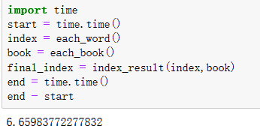

The 200m file running time is:

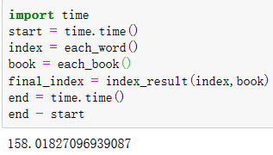

2.2 Map-reduce

This part I will use a map-reduce method to make a index.

First, I use a 10m file to do it:

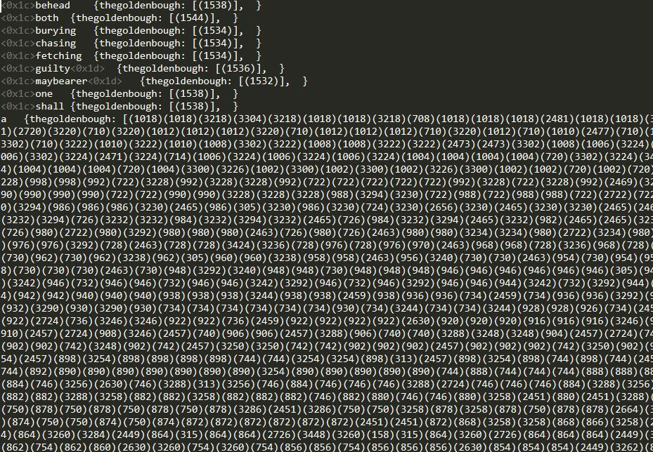

The result is like that. And the cost time is:

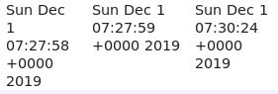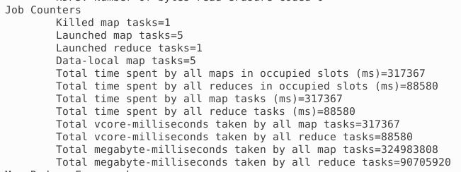

It’s about 150s.

And the 200m file cost:

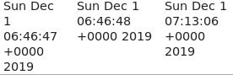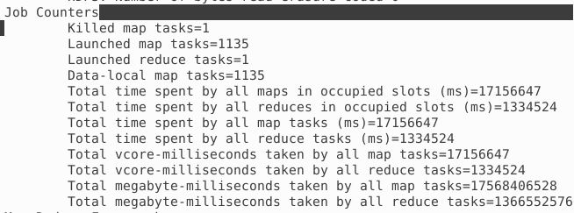

This cost about 26 minutes.

So, I think the map-reduce method is much slower than the Python method.

2.3 Lucene

In this project, I response to Lucene and Hadoop. Here I will show me my result. At first, I download some .jar bag of Lucene. Here are the bags.

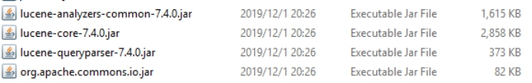

And I explain how these bags use. First is lucene-core-7.4.0.jar and org.apache.commons.io.jar. These two bags are the basic bag of Lucene. They form the structure of Lucene. I think everyone who have done this job know what is Lucene. It is developed by Java which is used to search for the whole document. So, this two bags include most of the resource which Lucene need. Next is Lucene-analyzers-common-7.4.0.jar. This bag conclude the analyzer of Lucene. Furthermore, I also have some Chinese analyzer, such as IKAnalyzer. This one I will introduce detailed later. The last one is Lucene-queryparser-7.4.0.jar. This one is an extra bag. It is use to search a sentence in the document.

Now I will introduce my project. This java file named LuceneFirst is a file used to create index and search index. Here is the code.

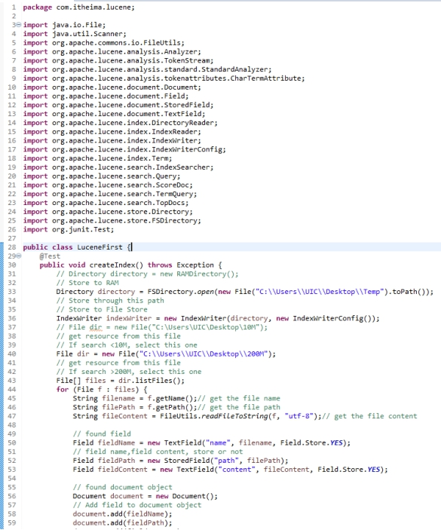

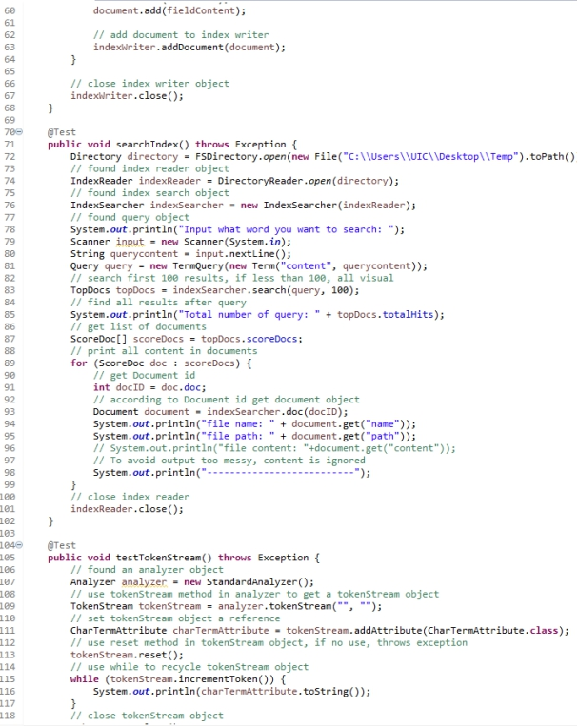

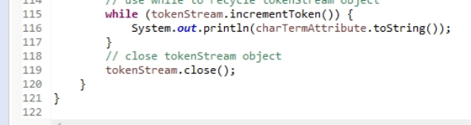

And know I will introduce some details. In createIndex method, I first found a directory object through the path. Directory of Lucene is in this file. And then use IndexWriter to get resource from path I write. I write two path according to two requirements in project, one is <10M (10M file), the other one is >200M (200M file). Then I took these files into several field, such as name, path, content, size. Then the directory is created. When I use the path of 10M, it cost about 1 seconds to create index.

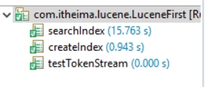

For 200M, it cost about 13 seconds.

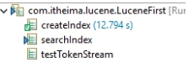

So, here is my method which is used to create index.

The second method is seachIndex. This is a method which is used to search some word of index. I first link to the file which has my index (create in first method). Then I make a question to users. This is used to guide users fill which words they want to search. For example, I want to search a word “today” in directory. Then, I will get this information.

This picture is a part of it of 10M.

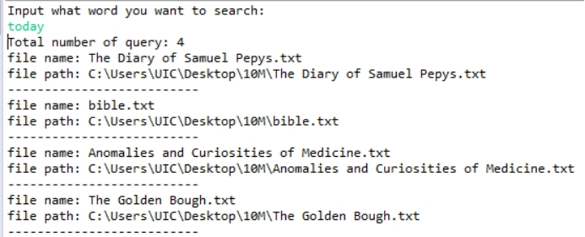This picture is a part of 200M.

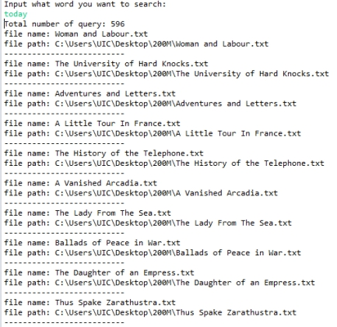

I get today this word is appeared in 596 texts. And I show file name and file path in this window. File content is ignored because I do not want to make this information messy. If you want to have a look. You can delete this comment icon in above code. The time I cost in 10M is 16 seconds.



For 200M is 1910 seconds.

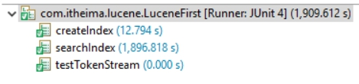

Compare with python, we can find the cost time of Lucene both much less than the cost time of python.

The last method is tokenStream. It is used to analysis the word which is let a sentence into a stack. This can large decrease the cost time of creating and searching index. Also, it can ignore some word and icon which have no mean and no one will search it. This can decrease the cost time of searching index too.

Another, I write a class which is used to search index. These method is an extra method of which I have talked. This is the code.

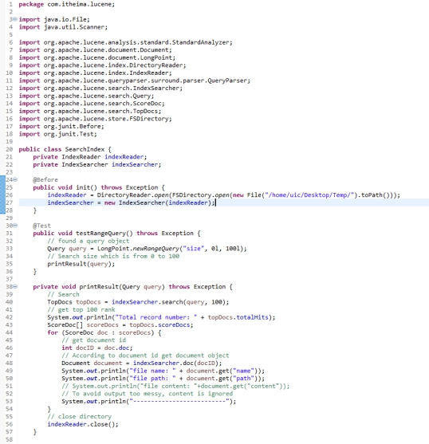

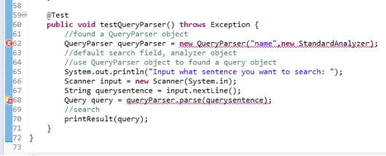

These methods both are very useful. The first one can search a word which appeared in a range times. For example, in my code, the word appeared from 0 to 100 times will be listed. The word “today” which appeared 596 times in 200M bag will be ignored here. The other method is QueryParser. This is used to search a sentence. In our daily life, we usually search a sentence in website. So, it is a very useful method. But unluckily, I have some wrong will my code which I could not debug. Wish you can help me if you know.

2.4 Ranking

Because a search engine needs to show the readers the strongest correlation first. So, we use the TF-IDF to rank the searching results.

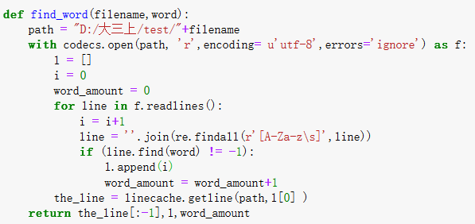

This first program is used to find out the word in each file. This function I find out the sentences where the searching words exist and use a list to store the line’s numbers. The last return result is that calculate how many words exist in this file.

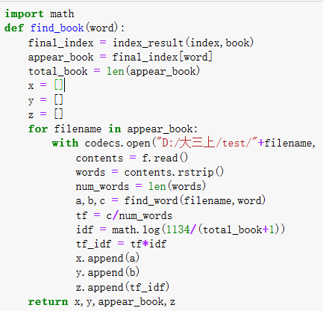

This method is used to find out the searching word in each related book. Here we use the find_word() function to can the word in each book’s positions, sentence and total amount. Then, in this function, I also calculate the TF and IDF. The return result is 4 list, one is the position, one is sentence, one is book list, last one is each book’s TF-IDF.

Because the results have the sentence about the searching word, but sometimes the sentence is so long that will cost too much time to print the result out. So, I use a function to shorten the sentence.

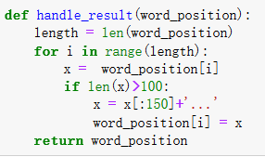

3 Web server and interface

3.1 Django

The name of our website is Moogle, which is a search engine that can perform search keywords, get the articles and paragraphs where the keywords are, and display the context. [Figure 1] is our search interface:



Figure 1

Our search box is the drop-down style of [Figure 2]. Users enter keywords here.

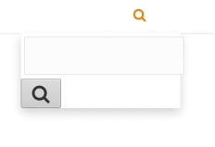

Figure 2

After the user enters a certain keyword to search, we want to show the user all articles that contain the searched keyword in the title. The user enters a search keyword in the search box, assuming "how" [Figure 3], and then the user clicks the search button to submit the results entered to the server. The server receives the search keyword "how" entered by the user and goes to the database Find all articles[Figure 5] with the keyword in the article title, and the server returns the query results to the user [Figure 4]. It also displays the search time and the number of search results.

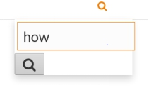

Figure 3

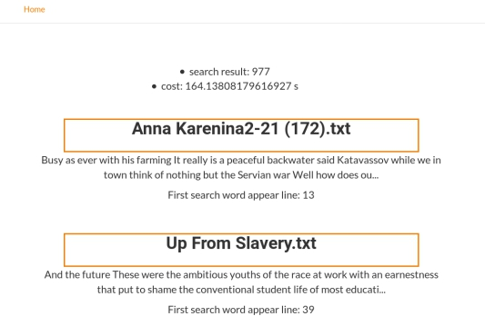

Figure 4

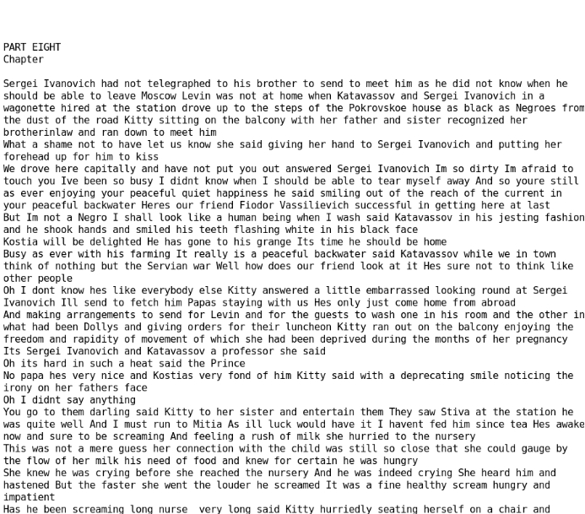

Figure 5

Figure 6 is the footer of the web page. The user can search for other keywords after viewing all the results, and can also view the most frequently searched keywords and recently viewed articles. But unfortunately, due to time, we did not complete the related tasks, paging and highlighting, which is where we need to improve.

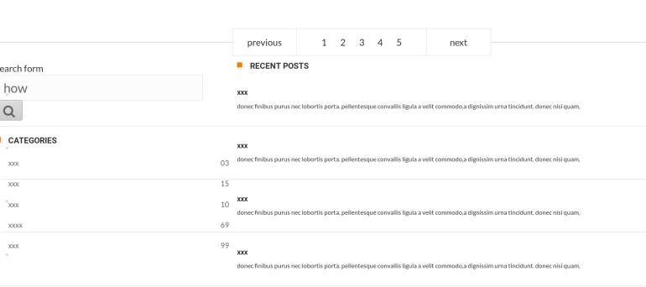

Figure 6

We also implemented a two-word search function that can run successfully and get results. [ Figure 7]

.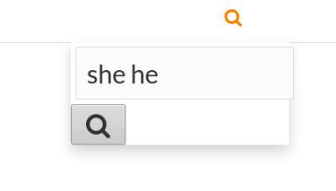

Figure 7

When the page is reduced, we also designed the upper navigation bar [Figure 8 ] and side bar [Figure 9]. Users can click the "Main menu" drop-down box and click "Home" to return to the home page; you can also search and view keyword popularity and history in the side bar.

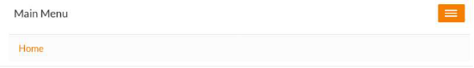

Figure 8

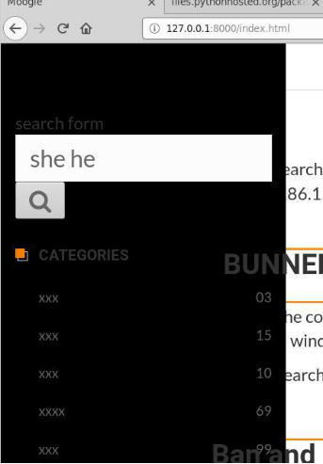

Figure 9

Here is the main implementation code:

The user enters search keywords in the search box, so we will provide a search form for the user on the web page. [Figure 10] is the html form code. In particular, there is a {% csrf_token%} under the form tag, which is the mechanism used by django to prevent cross-site request forgery (CSRF) attacks.

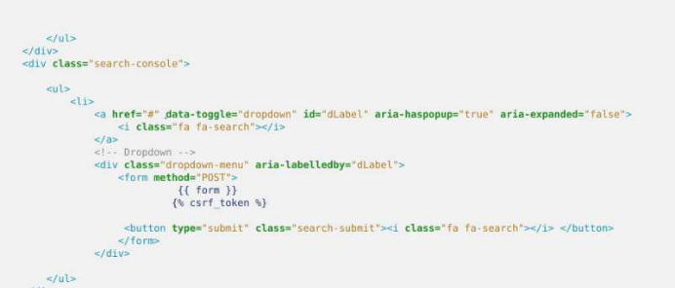

Figure 10

After the user enters the search keywords and clicks the search button, the data is sent to the django backend server. The form's action attribute has a value of / search /, indicating that the results submitted by the user will be sent to the / search / URL. [Figure 11] We use POST to upload keywords to the server. The data submitted by the user through the form django is stored in the form data body for us, and is passed to the URL pointed to by the action in a manner corresponding to the variables and values.

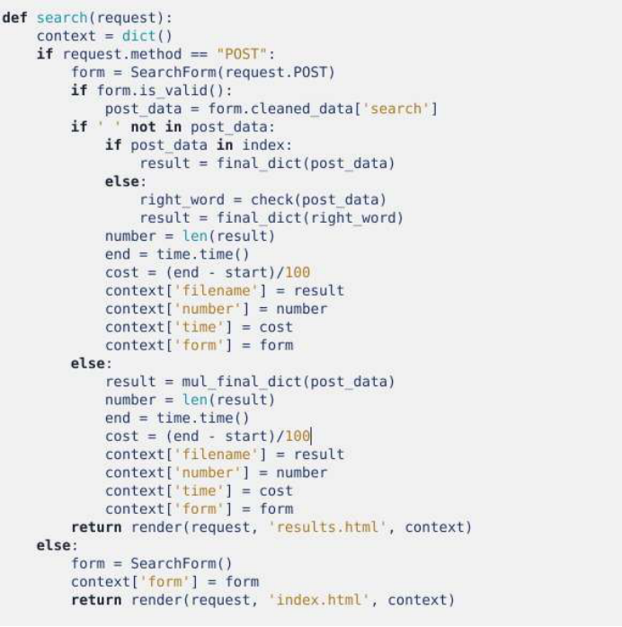

Figure 11

We use request.GET.get ('q') to get the search keywords submitted by the user. The data submitted by the user through the form django is stored in request.GET for us. This is an object similar to a Python dictionary, so we use the get method to get the value of the key q from the dictionary, which is the user's search keyword. [Figure 12]

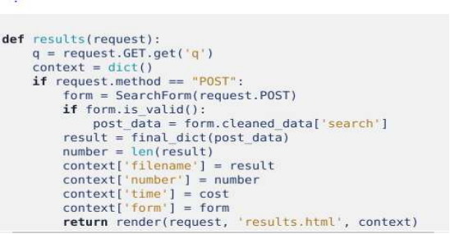

Figure 12

[Figure 13] is the search results page we rendered, showing a list of articles that match the search criteria.

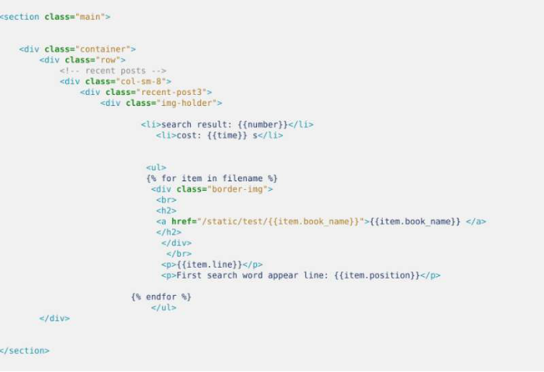

Figure 13

With the view function, we map the view function to the corresponding URL. The URL of our form data submission was ‘index ‘, so we bound the view function search to the URL. Because we need to implement the function of clicking ‘Home’ to return to the homepage, we need to add a URL to implement the function of returning to the homepage. [Figure 14]

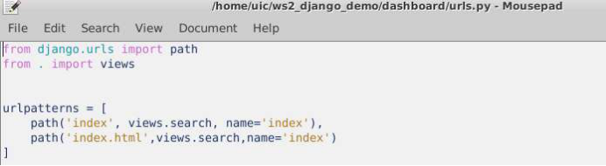

Figure 14

In the end, I think our system is very good. Except for some details that are not implemented, normal search functions can be done well.

3.2 Similar word

Because searching word always is spell wrong, so we need to find out the closest word of the searching word.

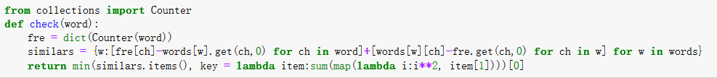

This method uses the KNN algorithm to calculate the nearest word in the word’s dictionary and then use that nearest word to replace the searching word.

First, I calculate the searching word’s frequency:

fre = dict(Counter(word))

Then calculate the distance between each letter in this word’s frequency and all of the word’s in the dictionary:

similars = {w:[fre[ch]-words[w].get(ch,0) for ch in word]+[words[w][ch]-fre.get(ch,0) for ch in w] for w in words}

Last, return the word which the sum of squares of letter frequency differences is the smallest:

return min(similars.items(), key = lambda item:sum(map(lambda i:i**2, item[1])))[0]

Then, I can get the closest word.

3.3 Multiple word

Because when we search word, we always import many key words, so this multiple word can achieve this result.

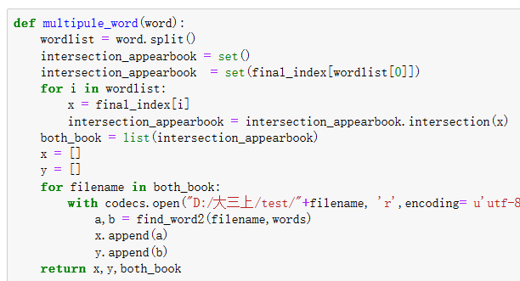

This method can find out the common book of each searching word. The method is close to the method I use to find only one word. The difference is this method need to add a step to find out the common book first. So, I use a set and loop to get a common book list. Then do search the word the same as mentioned before.

4 Lucene API and mantain

So, how can I get it from outside? I find a bag name Luke. This is used to compile the result of Lucene. Let me give you some photos. First I input the index Path and browse it.

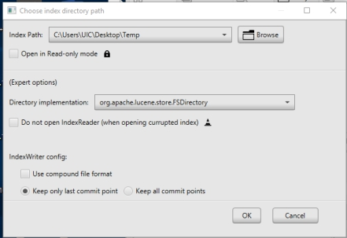

This is the result when I create an index of 200M.

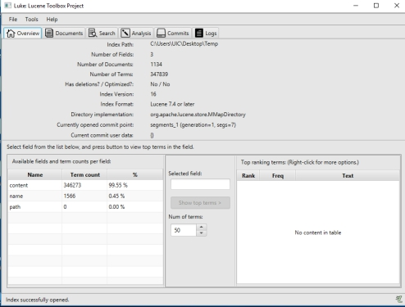

Here are 3 fields which are “content”, “name” and “path”. And here are 1134 documents and 347839 terms in it. Also get some information of Lucene. The version of Lucene is 7.4 and later and index Version is 16. When I select a filed, I click its field name and the button “Show top terms”. The ranking is appeared.

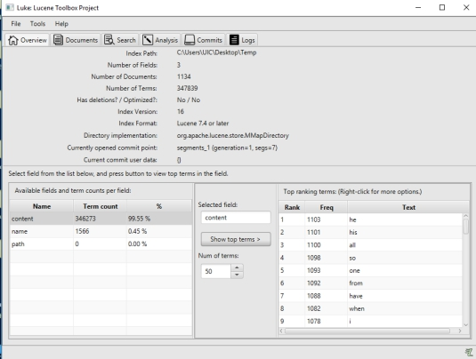

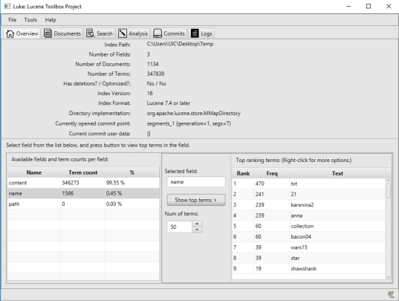

Here path is not stored because I want to save space (Which you can see in code, not TextField is StoredField). You also and search documents according to its id to read name path and content.

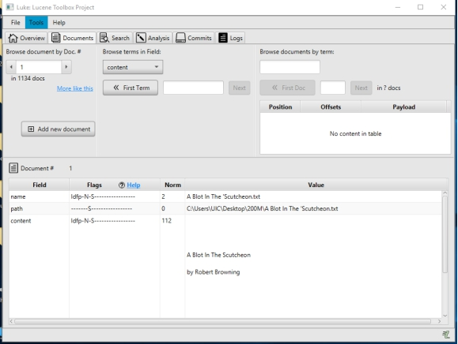

You also can search word and choose other analyzer in this programmer. But here I will not take it. Above is all of my code of Lucene.

Here is the extra part. In free time, I think about how to maintain our index. Here is the code. (The bug is IKAnalyzer, I did not build path here. Please ignore.)

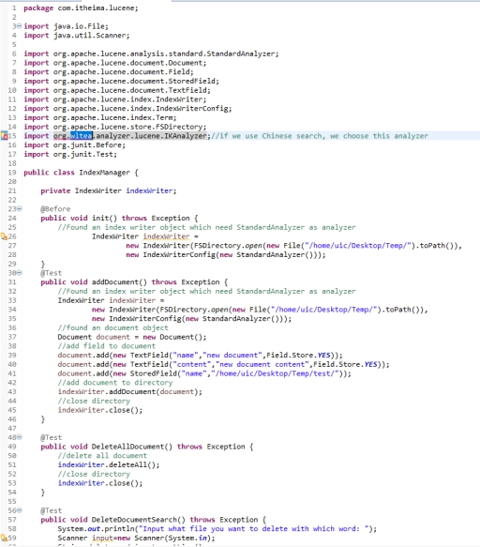

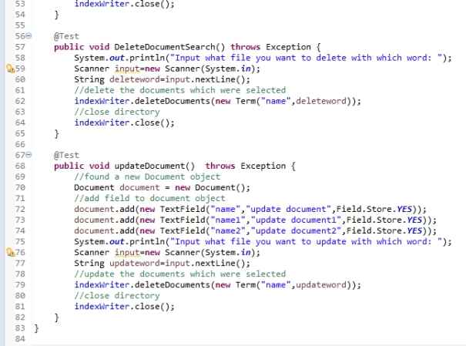

Here I wrote 4 methods are each used to add documents, delete all documents, delete particular document and update particular document. Maybe later I will find another better method or code. This is a screenshot when I add a document.

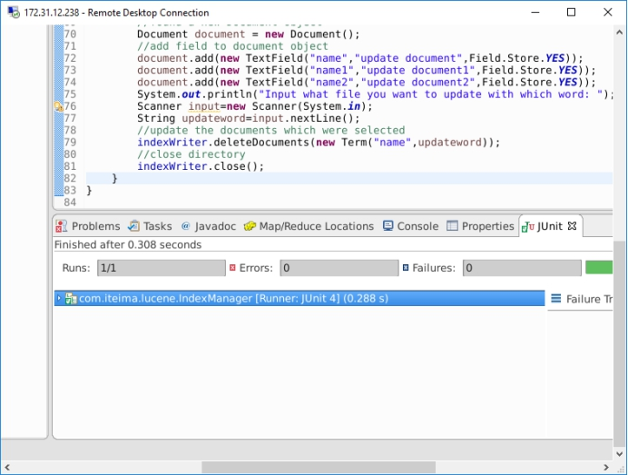

5 Improvement

First, because there are multiple words, so it needs to cost more time to get the result. Second, there have many TF-IDF results I can get, but can not do a rank. Because I don’t know which is the most important word. So, I need to use a new rank algorithm.

Second, the cost time is so large, I think this is because of too much for loop. So, I think we can use multi-process method to decrease the loop time. Also, the most part of cost time is due to print the result. So, I think I can use the multi-process to solve too.

Third, if I can connect to a database, I can use php to store each searching data. Then I can use this data to do a key word searching rank. Because a lot of searching engine has a ranking to find the hot spot key word.